# Part B: Supply Chain Analytics

## Introduction

The hypothetical scenario for this project is a real-life problem faced by a global furnishing retail company, which is the issue of managing inventory for their furnishing products. The company is struggling with maintaining an inventory level balance, as they face the problem of understock and excess stock. The understock issue results in loss of sales, and the excess stock issue leads to increased carrying costs, which can have a significant impact on the company's profitability.

#### Research Questions

How can the company achieve an inventory level balance and avoid understock and excess stock issues for their furnishing products?

#### SC Analytics

SC Analytics or Supply chain analytics can help the company address these issues by optimizing the inventory level, forecasting demand, and identifying the most profitable furnishing products. This information can be used to optimize the inventory level, reduce carrying costs, and improve profitability for their furnishing products.

According to Gartner (2021), supply chain analytics is "the application of advanced analytics to improve and automate decision-making across the supply chain." Supply chain analytics involves using various analytical tools such as descriptive, predictive, and prescriptive analytics to gain insights into the supply chain processes, optimize operations, reduce costs, and improve customer satisfaction (Bhattacharya et al., 2020).

#### Dataset

For this analysis, the Global Superstore dataset from Kaggle.com was used. The dataset contains historical sales data for a global retail company that sells various products, including furnishing products. The dataset has 51,290 records and 24 variables. I filtered the dataset to only include the furnishing product category to focus on the inventory management for these products. Variables used in the analysis include: Order Date, Ship Date, Product Name, Sales, Quantity, Discount, and Profit.

## Data Analysis

R was used to perform supply chain analytics, which includes data cleaning, data exploration, demand forecasting, inventory optimization, and profitability analysis for the furnishing products. Specifically, I will be using time-series forecasting models such as ARIMA to forecast demand for the furnishing products. I used optimization techniques such as linear programming to determine the optimal inventory level and minimize carrying costs.

Figure 1: Code Implementation of Data Selection

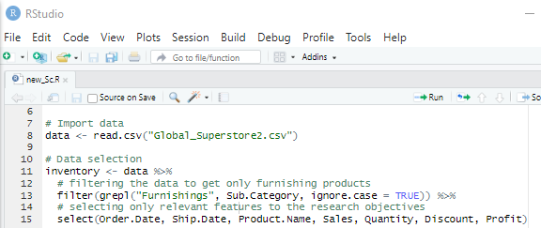

Descriptive Statistics: Next, I computed the descriptive statistics for the variables of interest, including Sales, Quantity, Discount, and Profit. The summary() function was used to obtain the summary statistics for these variables.

Table 1: Descriptive Statistics for Furnishing Products

|  |  |  |  |
| --- | --- | --- | --- |
|  | Sales | Quantity | Discount(%) |
| Min | 1.892 | 1.00 | 0.00 |
| 1st Qu. | 34.200 | 2.00 | 0.00 |
| Median | 73.312 | 3.00 | 0.00 |
| Mean | 121.633 | 3.54 | 0.15 |
| 3rd Qu. | 151.680 | 5.00 | 0.27 |
| Max | 1519.140 | 14.00 | 0.80 |

Figure 2: Distribution of Quantity for Furnishing Products

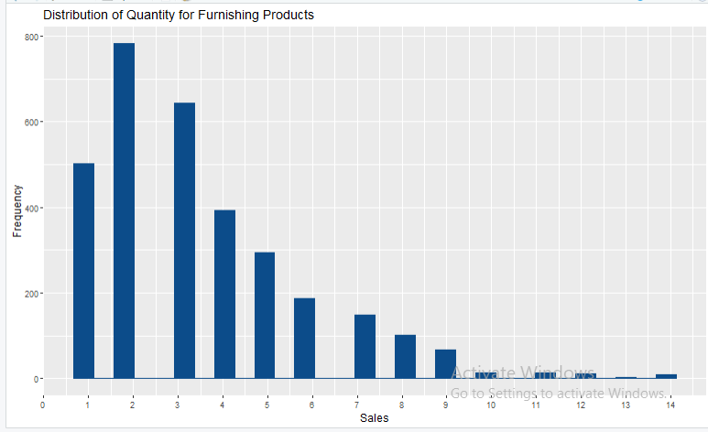

The descriptive statistics reveal that the mean quantity for the furnishing products is 3.54, with a minimum quantity of 1 and a maximum quantity of 14. And from Figure 2, the distribution indicates that most of the customers of this retail company buys between 1 to 6 quantities of furnishing product. The distribution of quantity for the furnishing products is also right-skewed, with a long tail on the right side. This can be caused by many reasons we will discover.

Figure 3: Daily Trend of Total Quantity of Furnishing Products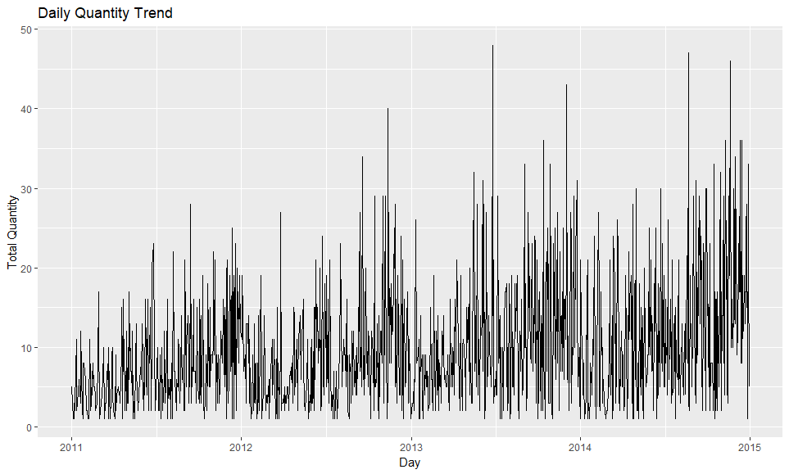

Based on the visualization in Figure 3, there is a possibility that the data is seasonal. However, further analysis is needed to confirm this hypothesis. To gain more precise insights into the pattern of the quantity, we have visualized the data on a monthly basis to identify any trends.

Figure 4: Monthly Trend of Total Quantity of Furnishing Products

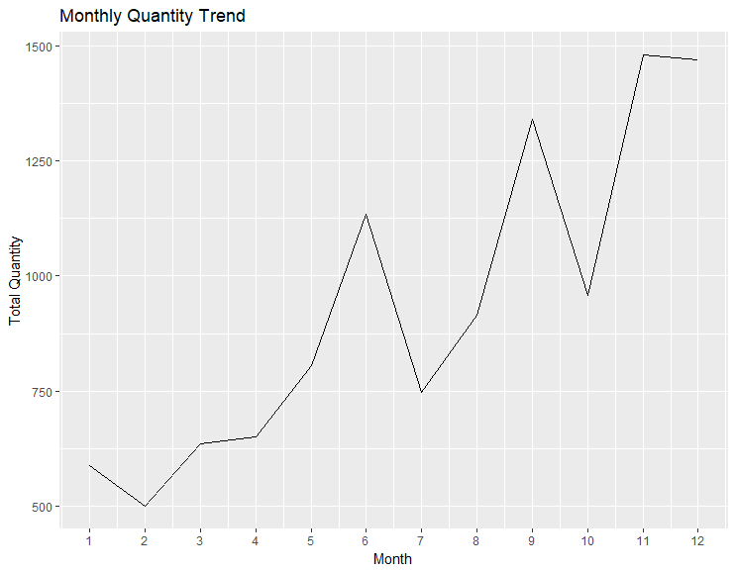

Based on the visualization of the quantity data on a monthly basis in Figure 4, we can observe that the data is seasonal. There appears to be a significant increase in the quantity of furnished products purchased in the months of June, September, November, and December. This insight can help the company.

Figure 5: Yearly Trend of Total Quantity of Furnishing Products

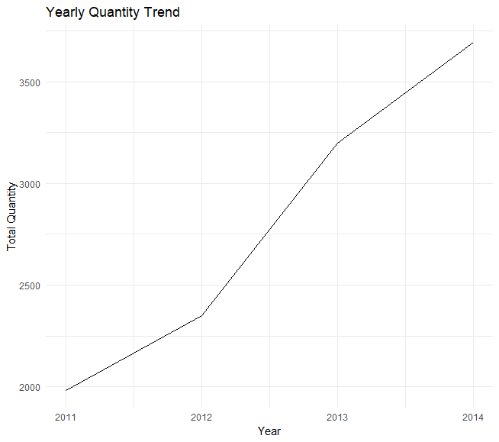

This visualization in Figure 5 indicates a steady increase in the quantity of furnished products purchased over the years. The growth and expansion of the country could be contributing factors to this trend.

Figure 6: Month Trend of Total Quantity of Furnishing Products per Year

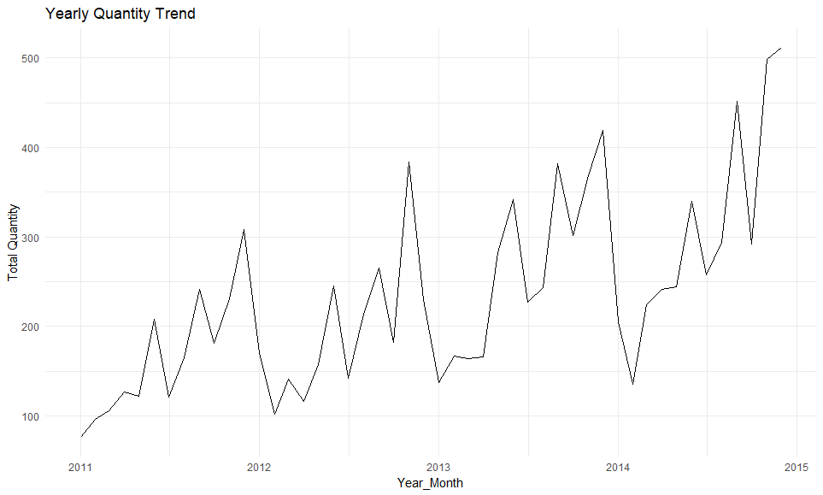

Based on the month yearly trend visualization in Figure 6, it appears that the seasonality pattern identified earlier is consistent across the entire period from 2011 to 2014. Specifically, the company consistently experiences a spike in the quantity of during the months earlier specified.

#### Forecasting Analysis

In order to project the quantity of furnishing products to be purchased in 2015, we employed an ARIMA (Autoregressive Integrated Moving Average) model. Through this analysis, we were able to generate a forecast for the quantity of furnishings products that is expected to be purchased across the year

Figure 7: Forecast for Total Quantity of Furnishings product for 2015

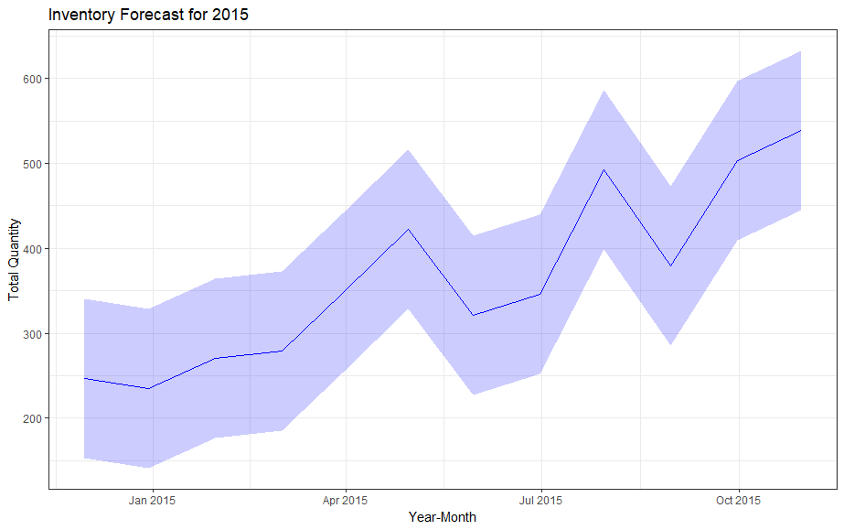

## Discussion and Conclusion

The findings suggest that they should anticipate higher demand for furnishing products during the months of June, September, November, and December. This could be useful information for the company to plan ahead and ensure they have enough inventory to meet the increased demand during those months. Ketter (2016) explained that anticipating seasonal demand can help businesses to optimize inventory management and reduce the risk of understock or excess stocks.

The visualization in Figure 6 shows that the quantity of furnishing products purchased has been increasing over the years, which could be a result of the growth and expansion of the country. Therefore, the company may want to consider expanding their product lines or increasing their production capacity to meet the growing demand for their products.

Additionally, based on the forecasting in Figure 7, the company can anticipate a slight increase in the quantity of products purchased for the year 2015 compared to the previous years. This could be taken as a positive sign for the company and a call to action for them to keep up with the growth and demand for their products. Makridakis, Wheelwright, and Hyndman (1998) explained that accurate forecasting can help businesses to optimize production planning, reduce costs, and improve profitability.

## Reference

Cooper, D. R., & Schindler, P. S. (2014). Business research methods. New York: McGraw-Hill Education.

Makridakis, S., Wheelwright, S. C., & Hyndman, R. J. (1998). Forecasting: methods and applications. New York: Wiley.

Fildes, R., & Nikolopoulos, K. (2017). Forecasting and planning: An evaluation. Journal of the Operational Research Society, 68(9), 969-981.

Hyndman, R. J., & Athanasopoulos, G. (2018). Forecasting: principles and practice (2nd ed.). OTexts.

Bhattacharya, A., Joshi, A., & Shankar, R. (2020). Supply chain analytics: A comprehensive review. Journal of Business Research, 114, 289-307. doi: 10.1016/j.jbusres.2020.03.013

Gartner. (2021). Supply chain analytics. Retrieved from <https://www.gartner.com/en/information-technology/glossary/supply-chain-analytics>